HOST INTRUSION DETECTION SYSTEM OSSEC
- Set up
Need at least two virtual machine that run linux ( can be Ubuntu or what ever,…) .
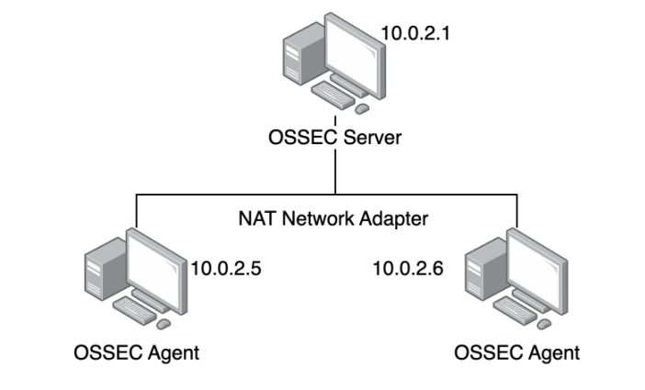
Then install OSSEC with the instruction below.

- Practice
OSSEC is a free, open-source, cross-platform, scalable host-based intrusion detection system (HIDS) with various security mechanisms. OSSEC can detect intrusions using both signatures and anomalies. Normal and anomalous signs are described in the OSSEC rulebook. OSSEC has a powerful analysis and correlation tool, integrating log monitoring and analysis, file integrity checking, Windows registry inspection, centralized policy enforcement, policy monitoring, rootkit detection, real-time alerting, and proactive response to ongoing attacks. These actions can also be predefined using rules in OSSEC to allow OSSEC to operate as desired by the administrator. In addition to being deployed as a HIDS, it is commonly used as a log analysis tool, monitoring and analyzing log records, IDS, web servers, and authentication logs. OSSEC runs on most operating systems, including Linux, OpenBSD, FreeBSD, Mac OS X, Sun Solaris, and Microsoft Windows. OSSEC can also be integrated into larger security systems such as SIEM (Security Information and Event Management). OSSEC can only be installed on Windows as an agent.

Advantages of HIDS: HIDS offers several improvements over NIDS
Suitable for the increasingly common encrypted data environment. HIDS can read encrypted data (logs) at the receiving server.
Suitable for switched networks where only the end host can see the traffic.
Monitors user usage processes at the server.
Capable of real-time detection and response.
Verifies the likelihood of an attack. NIDS typically provides an early warning, while HID can verify whether an attack or intrusion is likely to succeed or fail.
It also addresses attacks that NIDS cannot detect, such as fragmentation or session merging attacks.
-> For these reasons, OSSEC was developed based on HIDS rather than NIDS.

Key features of OSSEC include:
Log monitoring and analysis: OSSEC collects real-time logs from various sources for analysis (decoding, filtering, and classification) and provides alerts based on pre-established rules. OSSEC detects attacks on specific networks, systems, or applications using logs as its primary source of information. Logs are also useful for detecting software vulnerability exploitation, policy violations, and other forms of inappropriate activity. Some types of logs that OSSEC can analyze include proxy logs, web logs, authentication logs, and system logs.
File integrity checking: Using cryptographic hashing, the hash value of each file in the operating system can be calculated based on the filename, file contents, and this hash value is unique. OSSEC can monitor drives to detect changes to this hash value when someone, or something, modifies the file contents or replaces one version of a file with another.
Registry monitoring: The system registry is a directory listing all hardware and software settings, operating system configurations, users, user groups, and preferences on a Microsoft Windows system. Changes made by users and administrators to the system are recorded in registry keys so that the changes are saved when the user logs out or the system restarts. The registry also shows how the operating system kernel interacts with the computer's hardware and software. HIDS can monitor these changes to critical registry keys to ensure that users or applications do not install a new program or modify an existing program for malicious purposes.
Rootkit Detection: OSSEC detects rootkits based on signatures. A rootkit is a tool that allows an intruder to infiltrate a computer and erase traces of its existence. Intruders can use rootkits to steal information and resources from the victim's computer. OSSEC can detect rootkits by reading a database of rootkits and conducting periodic system scans, making system calls to detect unusual files, hidden processes, signs of privilege escalation, hidden ports, and comparing them to the database to detect rootkits.
Proactive Response: Proactive response allows IDS in general, and OSSEC in particular, to automatically execute commands or react when a specific event or set of events is triggered. Proactive responses can be defined by rules. The benefits of proactive responses are significant, but they are also dangerous, potentially blocking legitimate connections or creating vulnerabilities for attackers to exploit. For example, a legitimate administrator could generate false alarms and block legitimate users/servers from accessing the system if the rules are poorly designed.
- Install OSSEC
In this section, we will install and configure OSSEC like the below figure.

- Install OSSEC server
Install all the dependencies first before installing OSSEC.
sudo apt-get install build-essential make zlib1g-dev libpcre2-dev libevent-dev libssl-dev
sudo apt install libsystemd-dev
Download OSSEC, extract it, and install it.
wget https://github.com/ossec/ossec-hids/archive/3.7.0.tar.gz
tar -xvzf 3.7.0.tar.gz
cd ossec-hids-3.7.0
sh install.sh
After running the script, it will ask us some questions, at the question
1- What kind of installation do you want (server, agent, local, hybrid or help)? server
Type server
Then just press ENTER all if you do not want to read.
- Install OSSEC agent
Similar to installing the OSSEC Agent, we also need to install the supporting packages before installing OSSEC.
sudo apt-get install build-essential make zlib1g-dev libpcre2-dev libevent-dev libssl-dev
sudo apt install libsystemd-dev
Download OSSEC, extract it, and install it.
wget https://github.com/ossec/ossec-hids/archive/3.7.0.tar.gz
tar -xvzf 3.7.0.tar.gz
cd ossec-hids-3.7.0
sh install.sh
After running the script, it will ask us some questions, at the question
1- What kind of installation do you want (server, agent, local, hybrid or help)? server
Type agent
Then just press ENTER for all.
So, we have successfully installed the OSSEC Server and OSSEC Agent. In the next section, we will connect the Server and Agent.
- Connect the Server and Agent
To connect the Server and Agent, we use manage_agent. The steps include:
- Running manage_agents on the OSSEC server
o Adding the agent
o Extracting the agent key and copying it to the agent server
- Running manage_agents on the OSSEC agent
o Importing the extracted key
- Restarting the OSSEC management process on the server and starting the new Agent.
Note: During the server-client connection process, remember to open the port on the firewall so that
the server can communicate with the agent via UDP/1514.
First, on the OSSEC server, launch manage_agents using the following command:
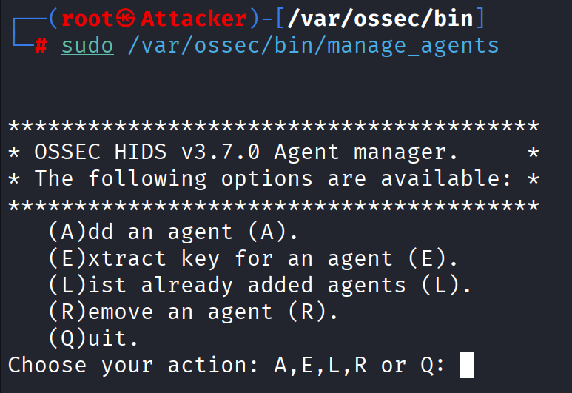
Enter A for new agent
Name the new Agent
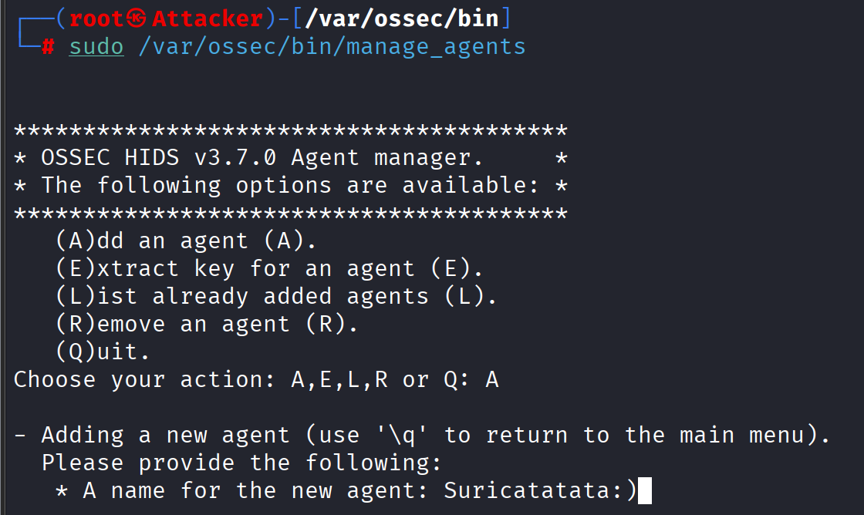

Assign an IP address to the agent:
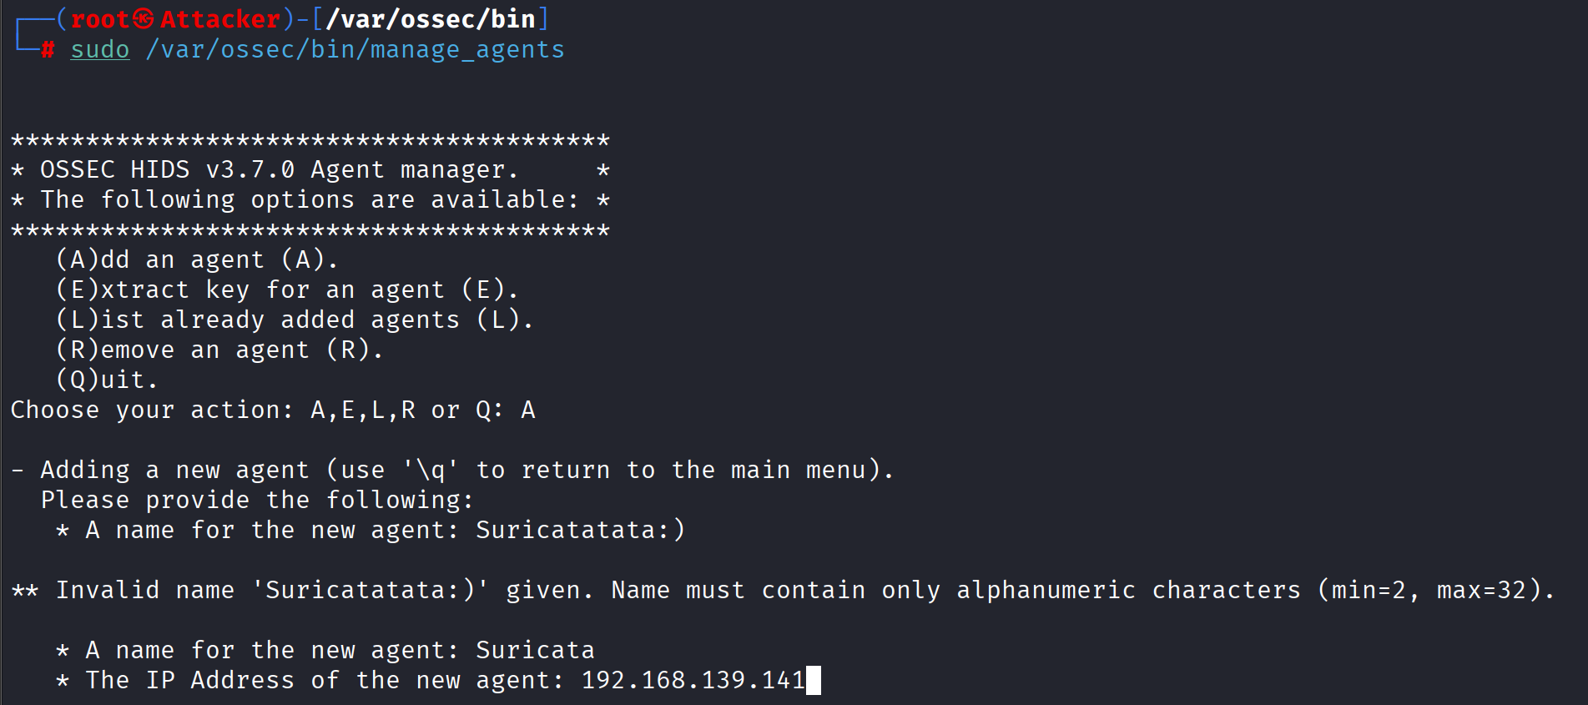
Press Enter for default ID, then confirm the information.
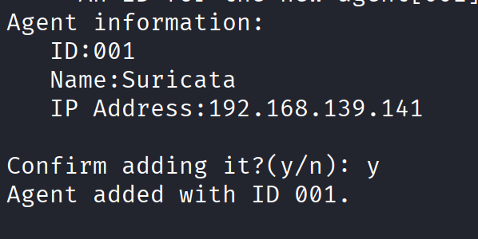
After adding an agent, a key will be generated. This key must be copied to the agent. To extract the key, use the “E” option in the manage_agents start screen. You will be provided with a list of all agents on the server. To extract the key for an agent, simply enter the agent ID.
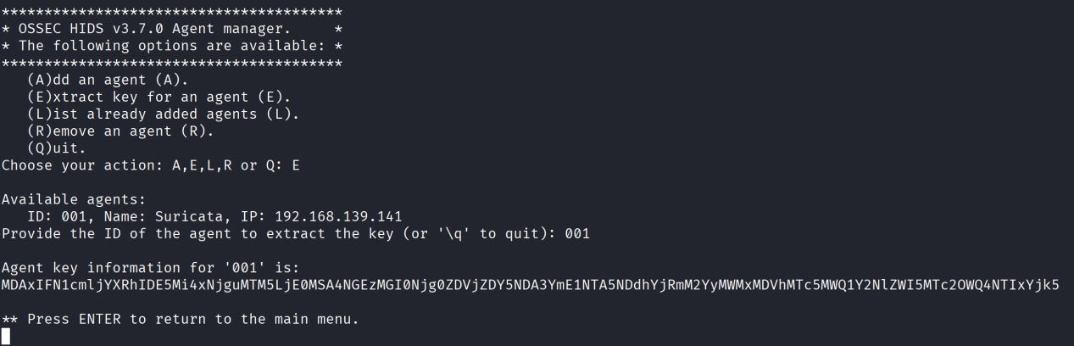

Next, we will import the key into the OSSEC Agent. In the Agent, run manage_agents
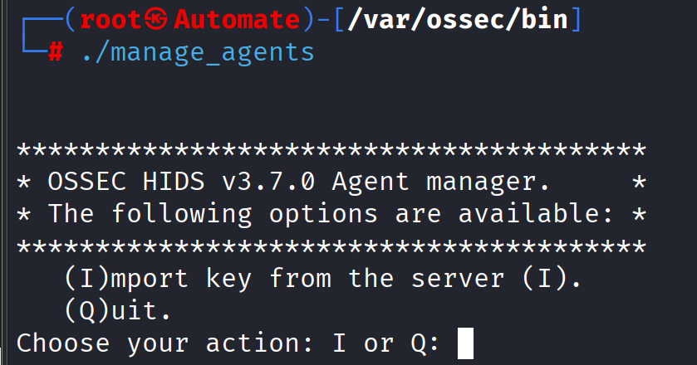
Select “I” and import the key extracted from the server.
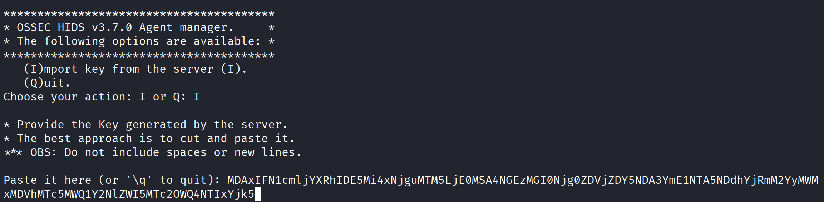
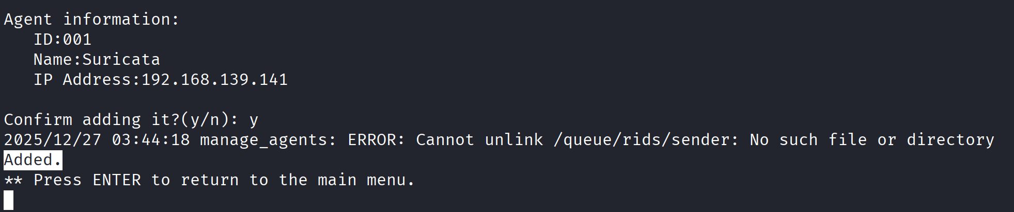
For the changes to take effect, restart OSSEC on both the server and the agent using the following command.
From agent
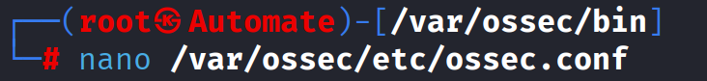
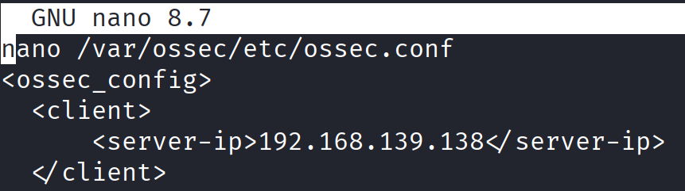
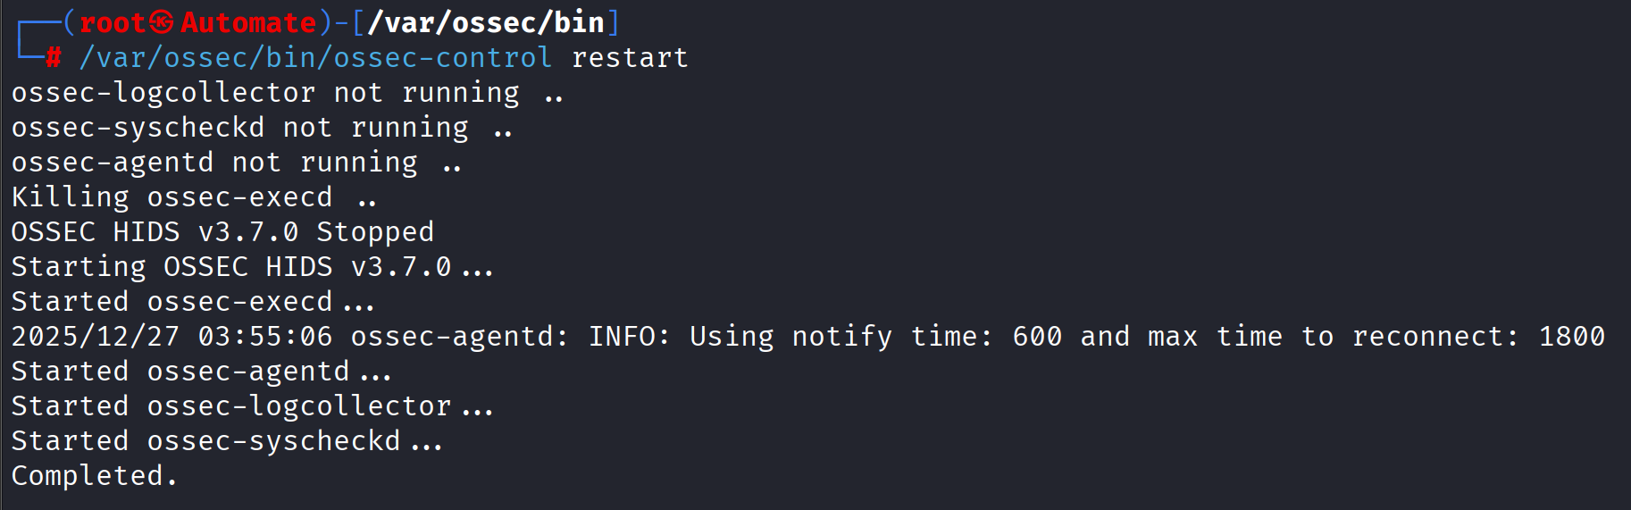
From server
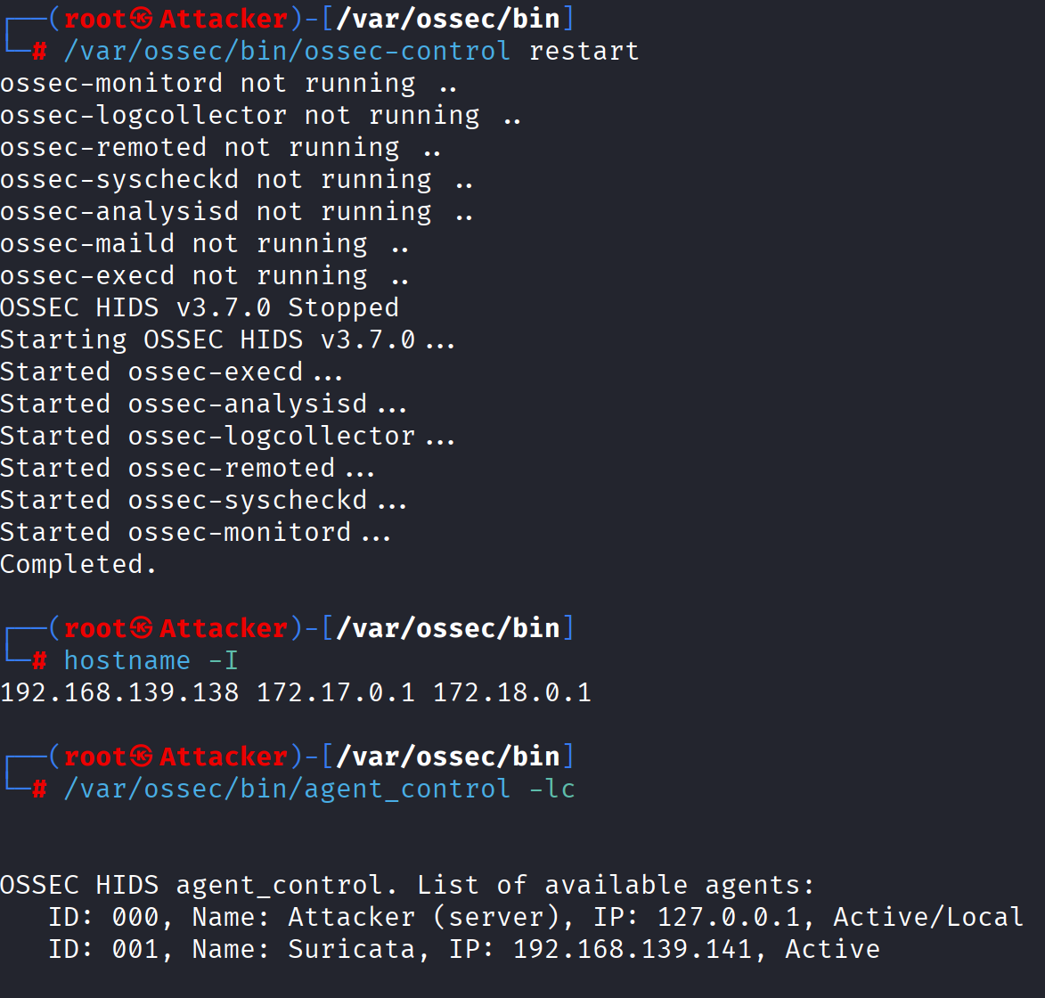

- Configure OSSEC
OSSEC configurations are stored in the file /var/ossec/etc/ossec.conf, playing a key role in customizing and optimizing the security system.
In this section, we will configure and test various scenarios to test the main features of OSSEC, including:
• Log monitoring: Monitoring application and system logs to detect unusual behavior.
• Integrity checking: Monitoring critical files to detect unauthorized changes, ensuring data integrity.
• Intrusion detection: Monitoring system logs and alerting when suspicious activity is detected.
• Proactive response: Taking automated actions, such as blocking IPs with suspicious behavior, to mitigate the risk of attack.
By deploying and testing these scenarios, we will evaluate the effectiveness of OSSEC in monitoring and protecting the system, as well as optimize the configuration to achieve the best security performance.
- Log monitoring
OSSEC can monitor log files from applications and systems to detect unusual behavior. By default, several system log files are pre-configured in the configuration file under the localfile. To configure which log files to monitor, simply define the log file format and the log file save location.
Task 1:Find the configuration file containing the log monitoring settings for the login process to the system. Note that this log file is located at /var/log/auth.log and is of type syslog. If it doesn't exist, add this configuration to the file. Then, on the Agent, log in using different users (root, local user, SSH user) and observe the alerts returned in the OSSEC Server log at /var/ossec/logs/alerts/alerts.log.

In order to do this task, I have to fix some problem for kali linux. Because this distro do not use syslog so it does not have auth.log
apt install rsyslog -y
systemctl enable --now rsyslog
After this, just open /var/ossec/etc/ossec.conf, then pass these new config on both server and agent.
<localfile>
<location>/var/log/auth.log</location>
<log_format>syslog</log_format>
</localfile>
Then restart both server and agent.
/var/ossec/bin/ossec-control restart
From now on, when ever I start my kali VM or change the user inside it, it always appear log alerts from server.
Change user log
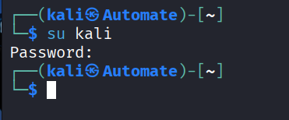
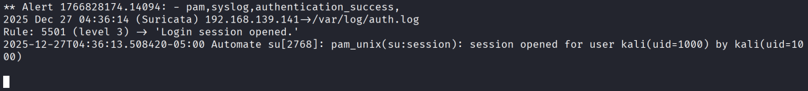
Start VM log

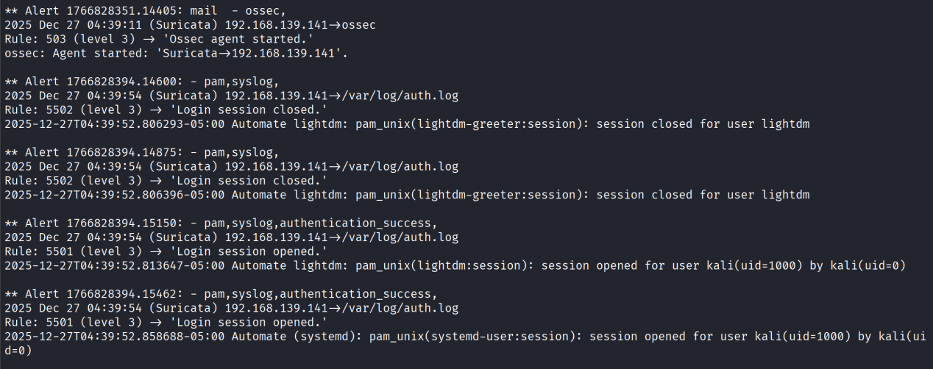
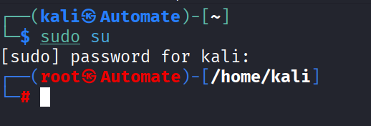
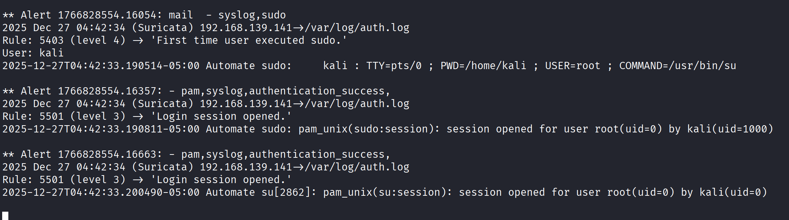
Create new user
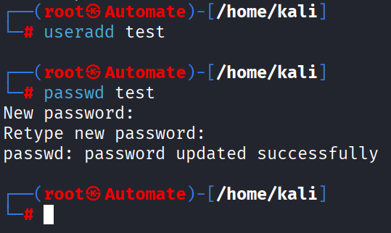
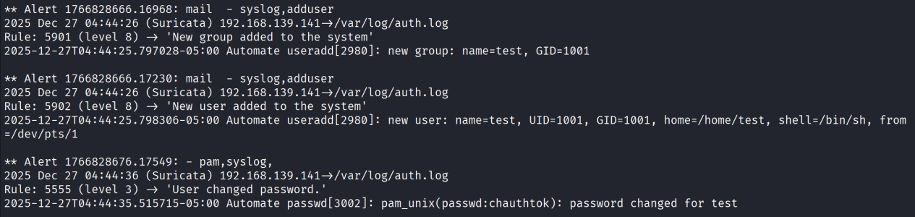
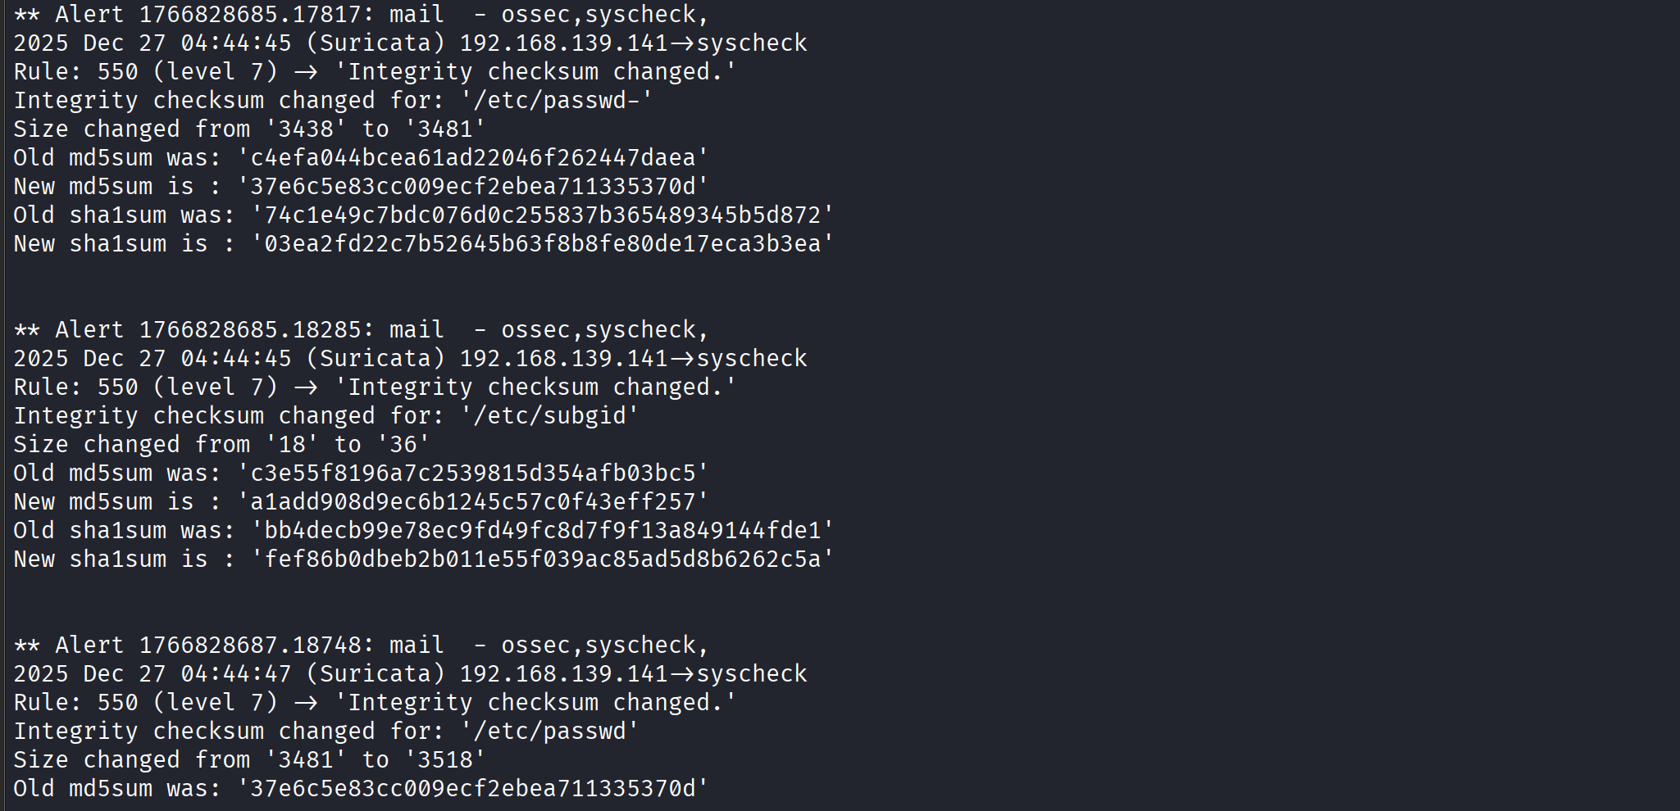
SSH alert
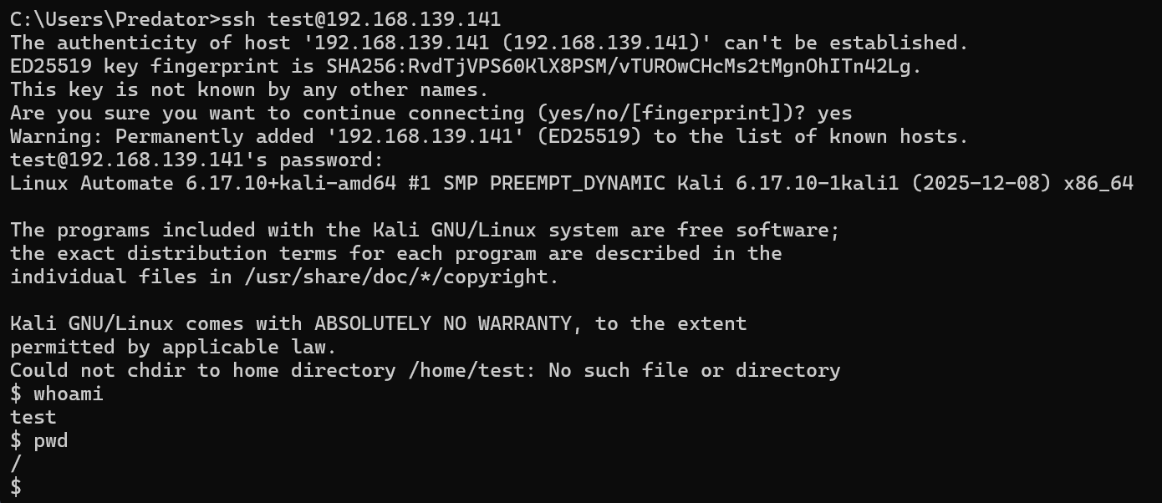
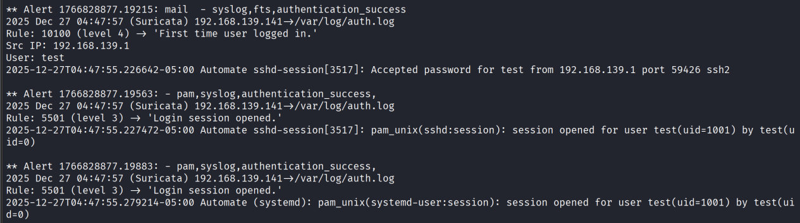
Each time an SSH login occurs, the system creates two separate PAM sessions: one for the sshd service and one for the systemd-user session. Because both events are logged to /var/log/auth.log, OSSEC HIDS detects and generates two corresponding alerts for the same login. This is normal behavior on Linux systems using systemd.
- File Integrity Monitoring ( FIM check )
In OSSEC, Syscheck is an integrity checking process that periodically scans files and registry entries (on Windows) to detect unusual changes. This is especially important because most types of attacks and attack vectors, from viruses to rootkits, leave traces on the system by changing or modifying certain files or operating system components.
OSSEC helps ensure system integrity by comparing MD5 or SHA1 checksums of critical files. Specifically, agents scan the system every few hours (customizable by the user) and send these checksums to the OSSEC server. The server stores the checksums and checks each change. If a modification is detected, the system triggers an alert to notify the administrator of the issue.
Task 2: Configure OSSEC to check the integrity of any directory. Then try modifying the contents of the files in that directory to prove the configuration was successful.
Create a new directory for testing this feature, then pass the new config to /var/ossec/etc/ossec.conf
<syscheck>
<directories check_all="yes"> /opt/ossec_fim_test</directories>
</syscheck>
syscheck = file integrity check module
check_all="yes":
detects: content modification, permissions, owner, hash
/opt/ossec_fim_test = test directory

- Active Responese
This feature allows OSSEC to perform automated actions, such as blocking IPs when detecting brute-force attacks, sending warning emails after multiple failed login attempts, etc. OSSEC's proactive response configuration is shown in the <ossic_config> tag.
Task 3:Refer to the OSSEC active response syntax (https://www.ossec.net/docs/syntax/head_ossec_config.active-response.html) and configure blocking IPs when suspicious traffic is detected (such as multiple failed login attempts). Perform an attack to test the accuracy of the configuration.
Checking the connection before doing the active response.
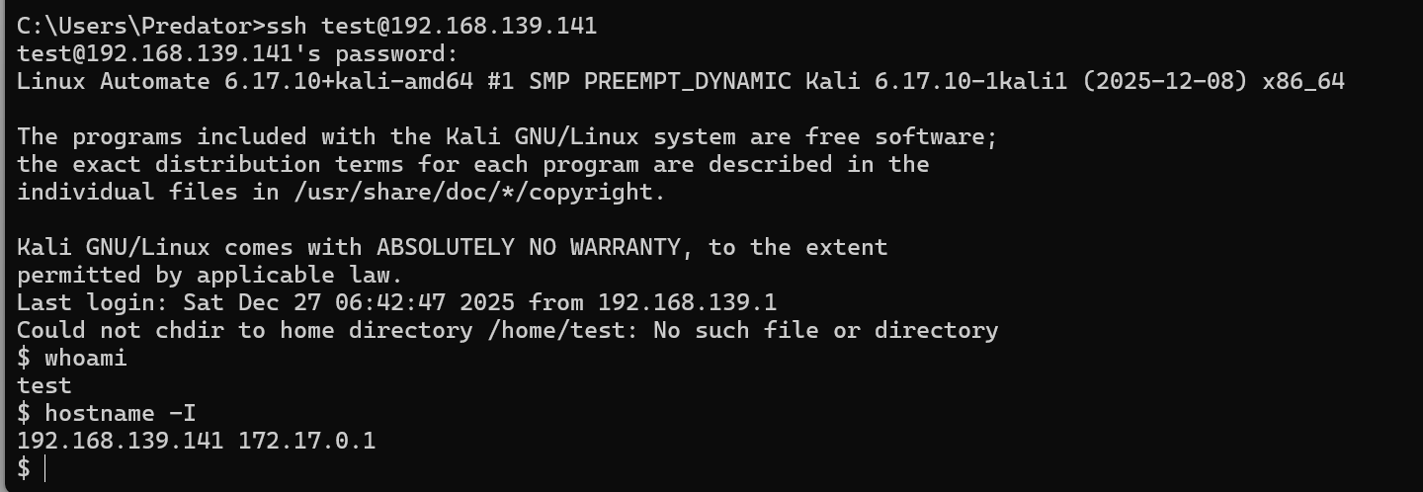
Checking iptables status before doing the active response.
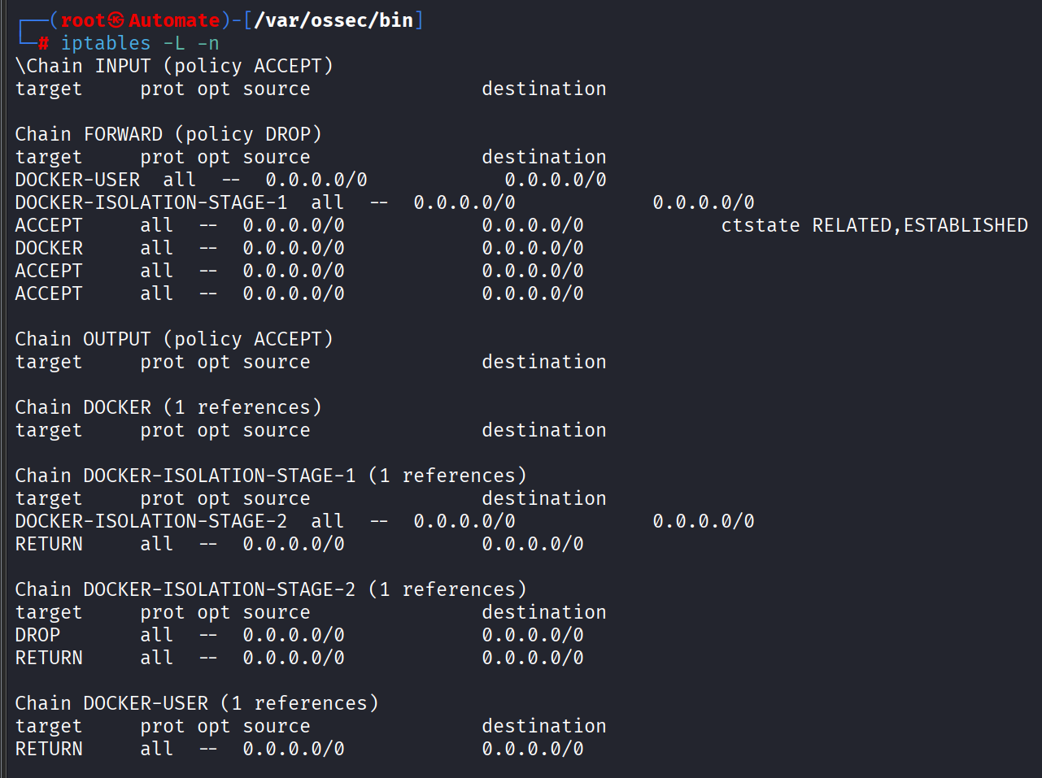
Activate command and active response on server.
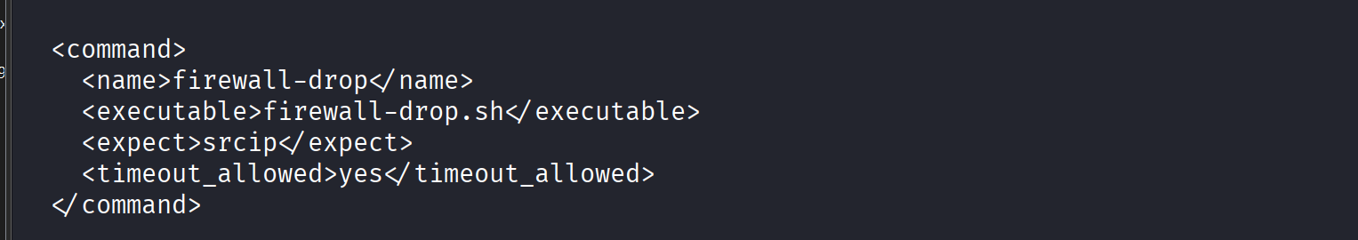
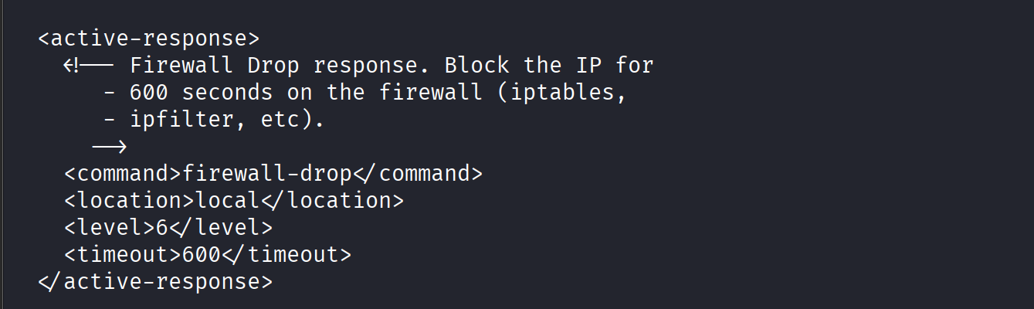
Check required script on agent.
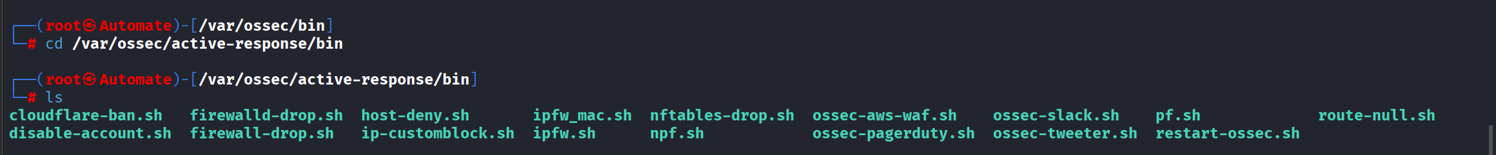
Attacker
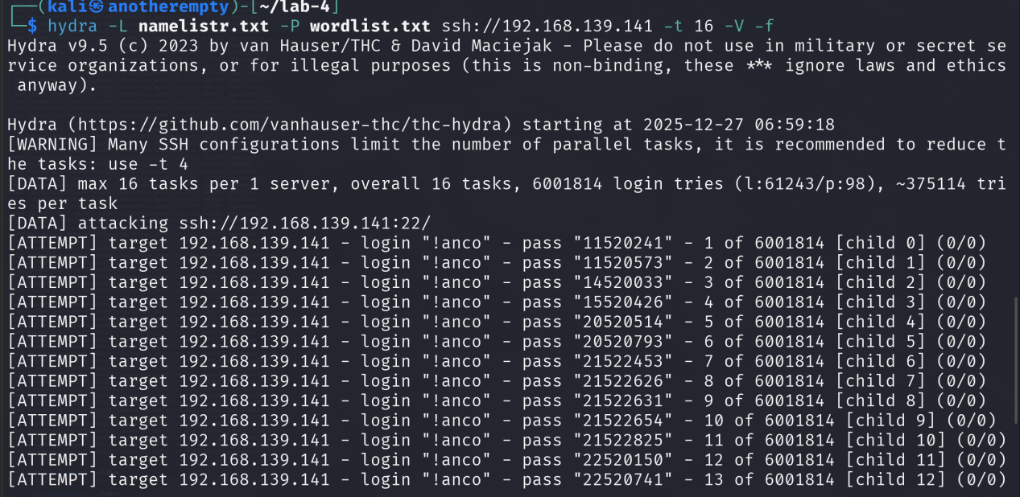
Alert
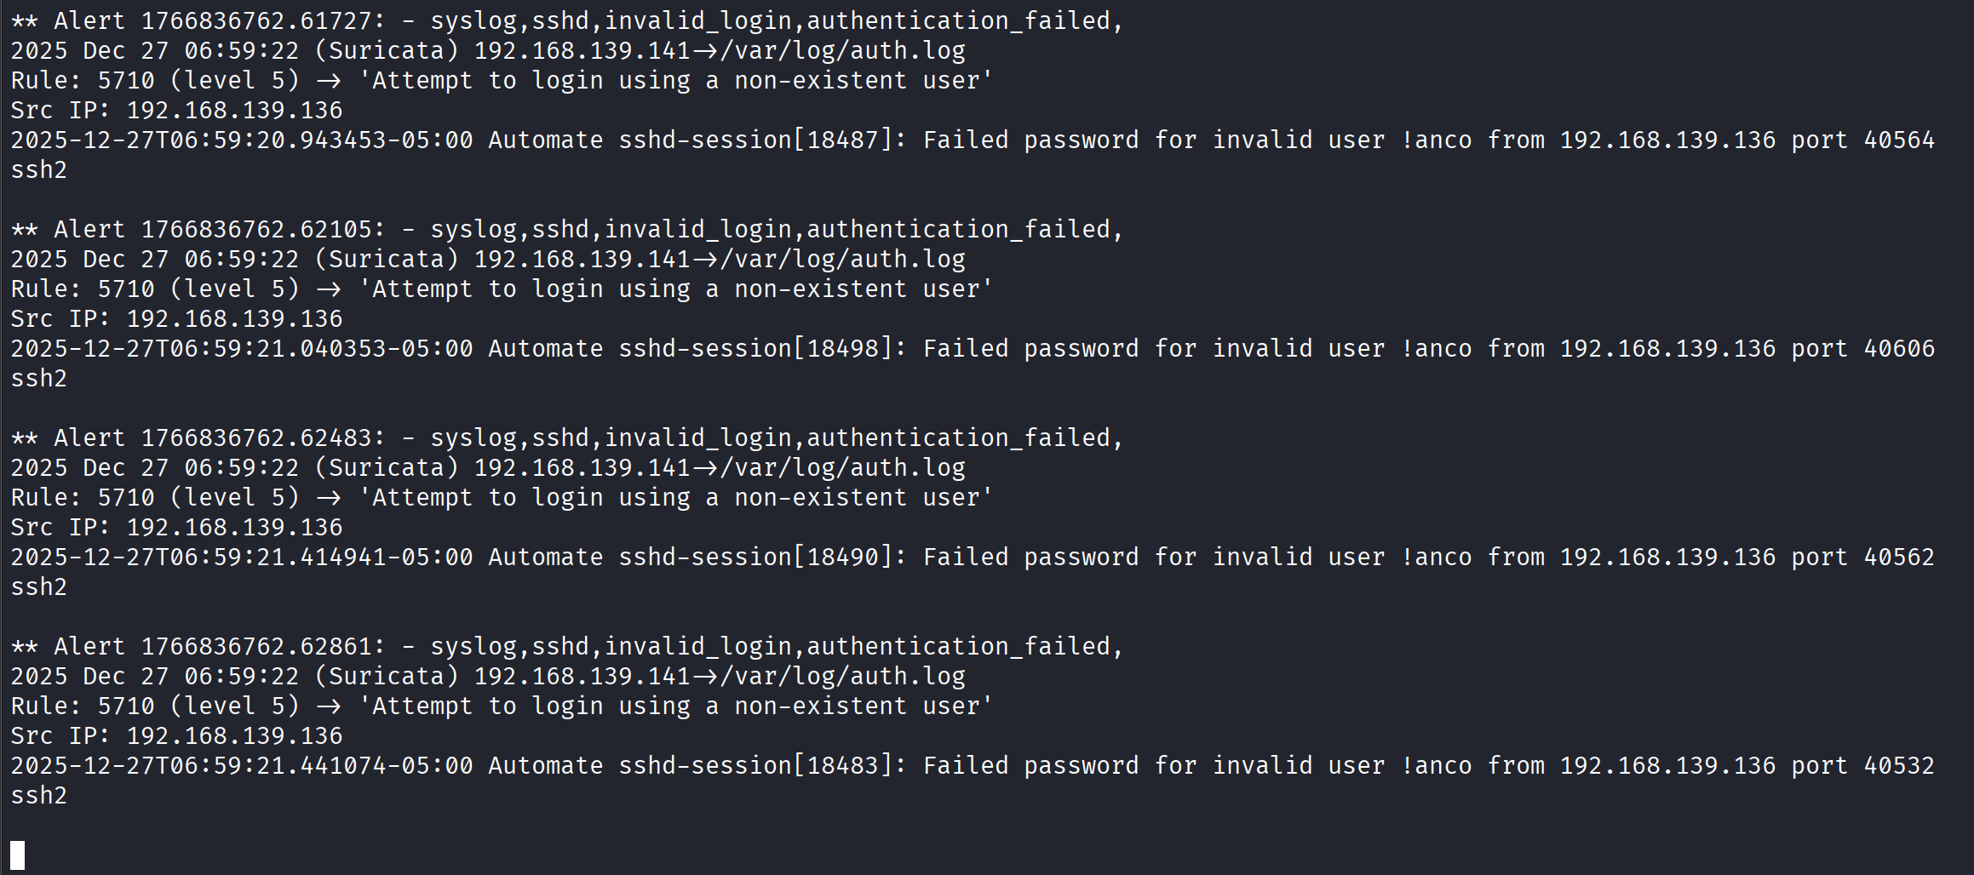

Agent update new rule for iptables to block unauthorized access from IP 192.168.139.136
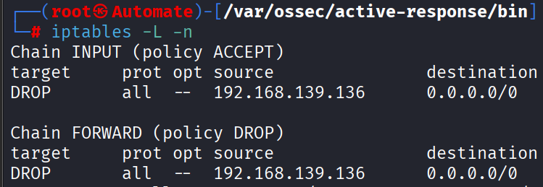
Attacker was refused to establish a connection.
